**DAILY HABITS AND LIFESTYLE**

**(looker studio)**

Group members:  
Mark Lopes-9913

Vivian Ludrick-9914

Rohit Patra-9928

|  |  |
| --- | --- |
| **Table of Contents:** | |
| Introduction | 1 |
| Definitions & Examples | 2 |
| Survey Questions and Analysis Report | 3 |
| Data types | 8 |
| Key findings | 9 |
| Conclusion | 10 |
| Your creative project | 11 |

**Introduction**

This report provides a detailed analysis of daily habits and lifestyle choices, based on a survey conducted with 70 respondents. The survey comprised 13 questions, designed to explore various aspects of individuals' everyday routines, personal habits, and overall well-being. Key areas of focus included daily activities, exercise routines, dietary habits, time management strategies, and satisfaction with their current lifestyle. The insights gained from this survey offer valuable information about common trends, preferences, and behaviors, helping to understand how people structure their day-to-day lives and make choices that impact their health and productivity.

**Definition and Examples**

1. Nominal Data:

Definition: Nominal data is used for labeling or categorizing without implying any sort of order.

Examples:

* Colors (red, blue, green)
* Nationality (American, Canadian, Indian)

1. Ordinal Data:

Definition: Ordinal data has a natural order or ranking, but exact differences between ranks may not be known.

Examples:

* Education level (high school, bachelor's, master's)
* Movie ratings (1 star, 2 stars, 3 stars)

1. Numeric Data:

Definition: Data that represents measurable quantities and is expressed as numbers. It shows the magnitude of values and can be analyzed mathematically.

Examples:

* Number of steps per day
* Hours spent working.

1. Interval Data:

Definition: Interval data has equal intervals between consecutive measurements, allowing for addition and subtraction, but no true zero point.

Examples:

* Temperature in Fahrenheit (0°F to 100°F)
* IQ scores (measured on a scale with equal intervals)

1. Ratio Data (previously referred to as Record Data):

Definition: Ratio data has all the properties of interval data, plus a true zero point for comparison.

Examples:

* Height (measured in inches or centimeters)
* Weight (measured in pounds or kilograms)

**Survey Questions & Analysis Report**

**Nominal Data**

1.What is your primary source of news?* 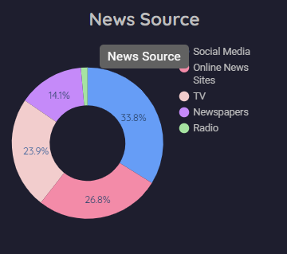

2. Which social media platform do you use most often?

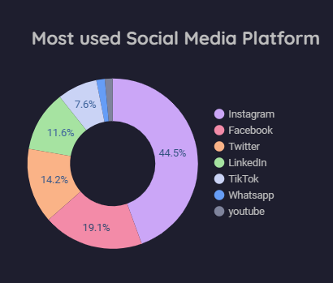

3. Which type of exercise do you prefer?

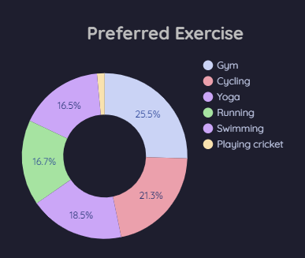

**Ordinal Data**

4. How often do you exercise?

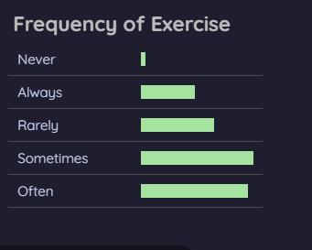

5. How would you rate your overall stress level?

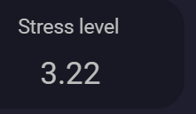

6. How satisfied are you with your work-life balance?

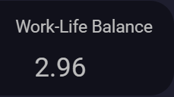

7. How often do you eat out in a week?

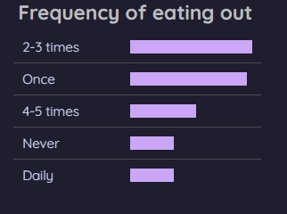

8. On a scale of 1 to 5, how energetic do you feel throughout the day? (1-low, 5-high)  
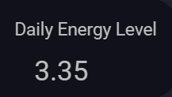

**Numeric Data**

9. What time do you usually go to bed?  ( 24-hour format, ex 23:00)

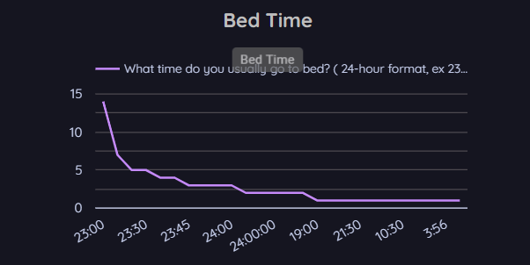

10. How many hours do you spend working or studying each day?

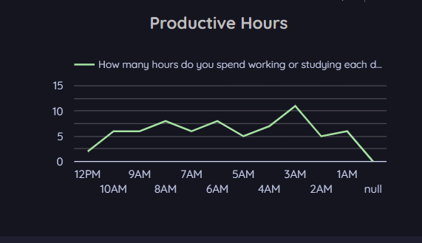  
11. How many cups of coffee or tea do you drink per day?

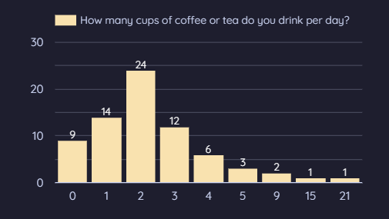

12. How many steps do you walk on an average day?

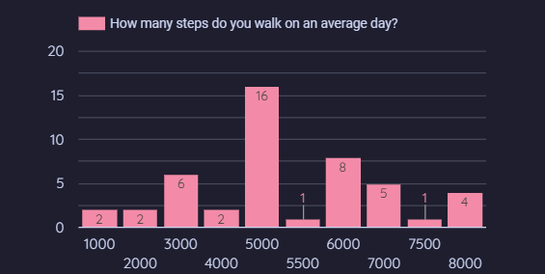

**Interval Data**

13. What is the average temperature in your area? (in Celcius)

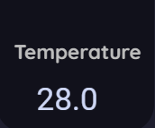

**Survey Structure:**

The survey contains 13 questions, focusing on customer insights through four data types:

* Nominal Data: Captures preferences for most used social media platform, news sources and preferred exercise.
* Ordinal Data: Measures satisfaction and importance of various aspects like frequency of exercise, work-life balance, stress level, daily energy level and frequency of eating out.
* Numeric Data: Measurable quantities which expressed as numbers like bed time, productive hours, numbers of tea or coffee and average per day walk.
* Interval Data: Evaluates customer experience and satisfaction on a 1-10 scale.

**Data Types**

**Nominal Data Analysis:**

* Most used Social Media platform
* Primary Source of news
* Most preferred exercise

**Ordinal Data Analysis:**

* Frequency of exercise
* Daily work-life balance
* Daliy Energy level
* Frequency of eating out
* Stress level

**Numeric Data:**

* Bed time
* Hours spend on working or studying
* Numbers of tea or coffee per day
* Average per day walk

**Interval Data:**

* Average temperature in your area

**Key Findings**

**Nominal Data Insights:**

* Instagram emerged as the most popular social media platform among respondents.
* The majority of respondents rely on online news portals for their primary news source.
* Walking was identified as the most preferred form of exercise.

**Ordinal Data Insights:**

* Most respondents exercise sometimes, indicating moderate activity levels.
* A significant portion of respondents rate their work-life balance as "good," with few extremes on either end.
* Respondents generally report having "average" energy levels throughout the day.
* The majority of respondents eat out 2-3 times a week.
* Stress levels are mostly rated as "moderate," with some respondents experiencing higher stress occasionally.

**Numeric Data Insights:**

* The average bedtime for respondents is around 11 PM.
* Respondents spend an average of 3-4 hours per day working or studying.
* On average, respondents consume 1-2 cups of tea or coffee daily.
* Most respondents walk an average of 5,000-6,000 steps per day.

**Interval Data Insights:**

* Overall an average temperature of 28℃ is being recorded.

**Conclusion**

The survey provides valuable insights into the daily habits and lifestyle choices of respondents. Key findings indicate that most individuals prioritize moderate exercise and maintain a generally good work-life balance. Additionally, respondents exhibit a consistent daily routine, characterized by an average bedtime of 11 PM and a substantial commitment to work or study. Consumption of tea or coffee is moderate, reflecting typical daily routines. Overall, these insights highlight the importance of understanding individual behaviors for fostering a healthier and more balanced lifestyle.

Recommendations for improving daily habits and lifestyle:

1. **Exercise Regularly:** Aim for at least 30 minutes of physical activity most days to enhance fitness and well-being.
2. **Maintain a Sleep Schedule:** Establish consistent bedtime and wake-up times to improve sleep quality and energy levels.
3. **Limit Caffeine Intake:** Reduce coffee and tea consumption, especially in the afternoon, to promote better sleep.
4. **Enhance Work-Life Balance:** Set clear boundaries between work and personal life to allow for relaxation and leisure.
5. **Plan Healthy Meals:** Prepare balanced meals to minimize eating out and ensure adequate nutrition.

Implementing these strategies can lead to a healthier and more balanced lifestyle.

**Your creative project**

Looker Studio Dashboard:

